Old queen problem code

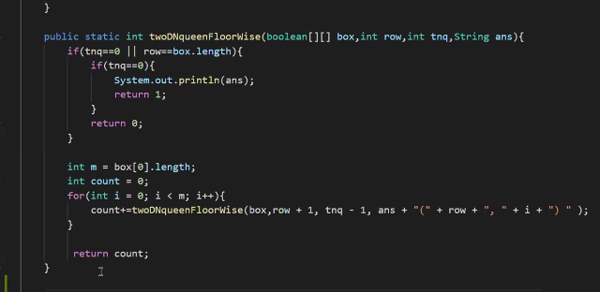

Nqueens

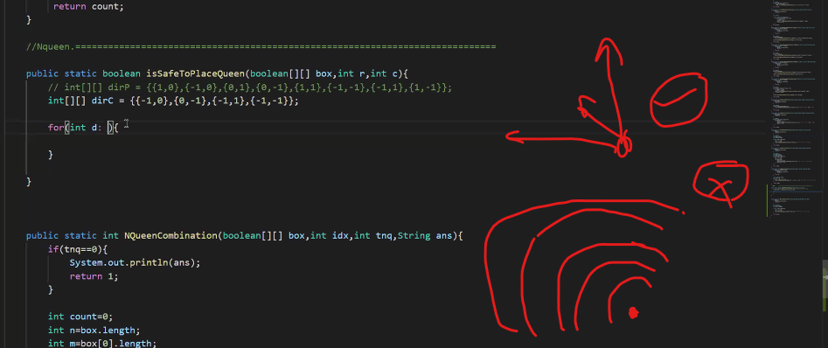

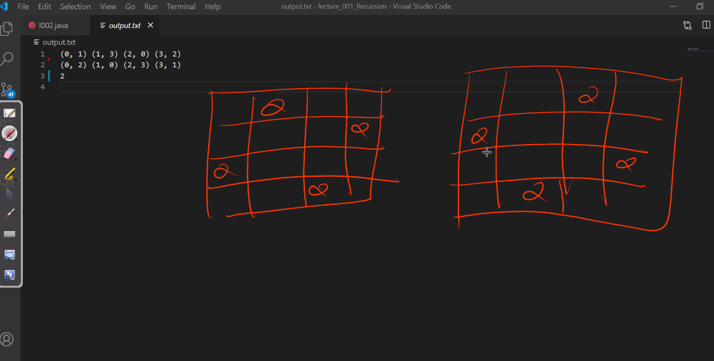

**LEETCODE NQUEENS -52, 51**

**Different possible solutions**

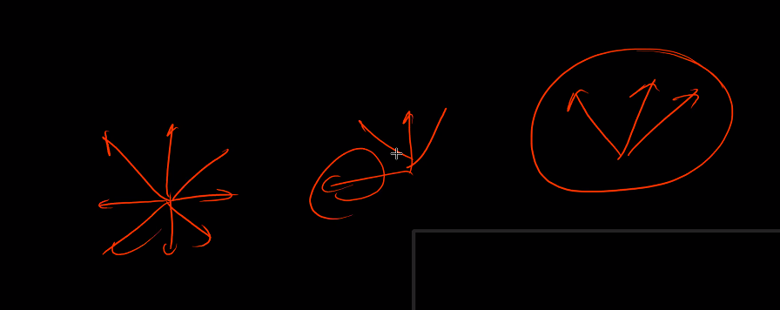

**Best answer for the problem**

**1-check for is queen is safe or not**

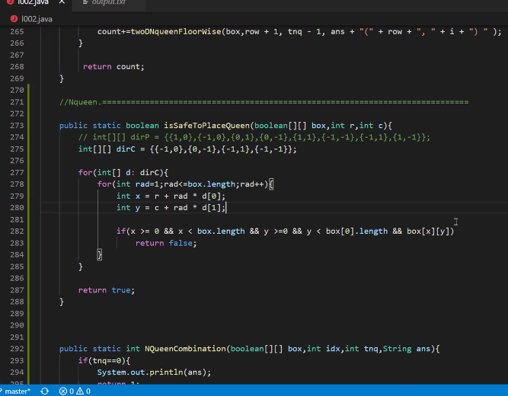

**TREE FOR WORD BREAK PROBLEM GFG**

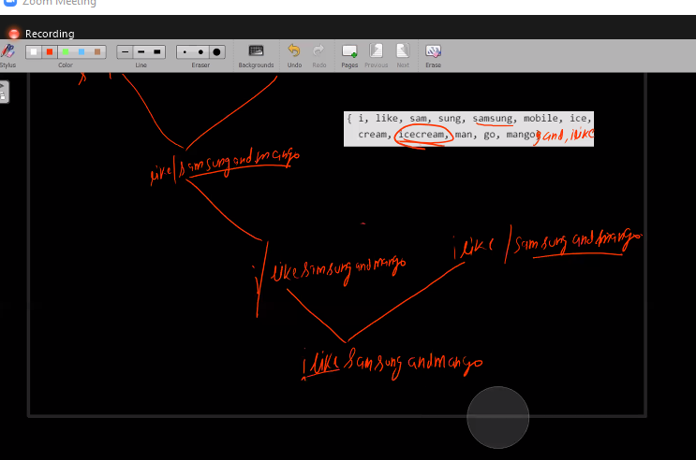

**Hamesha koshihsh kare ki aap usko substring use na kare because this is a bad habbit because it a O(n) function and can increase your complexity without you known so in that case prefer to use index method\**

**CRYPOGRAPHICH SEND MORE MONEY**

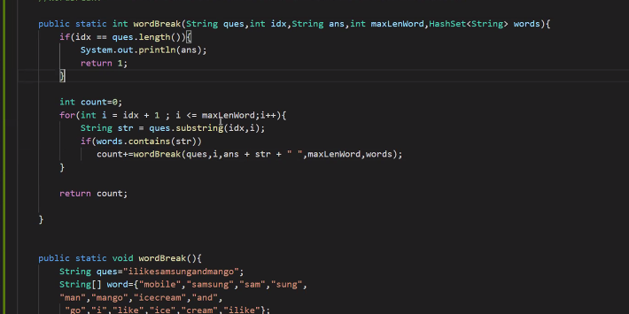

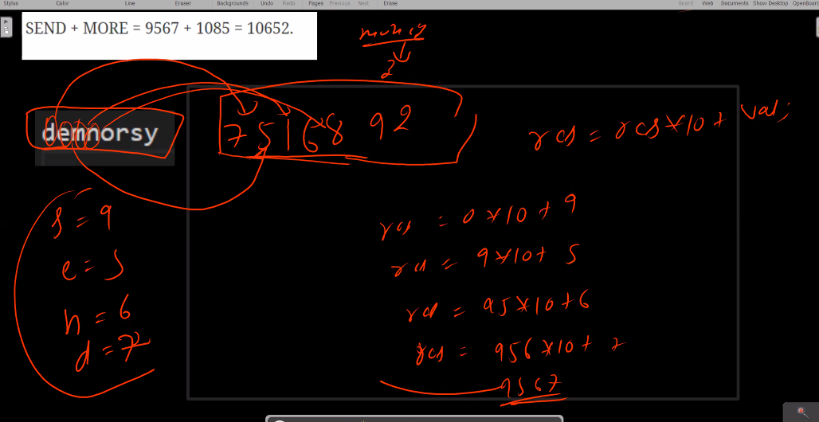

**Crypto code**

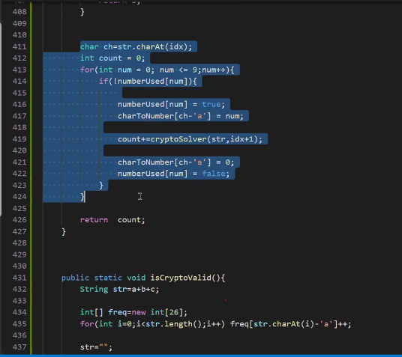

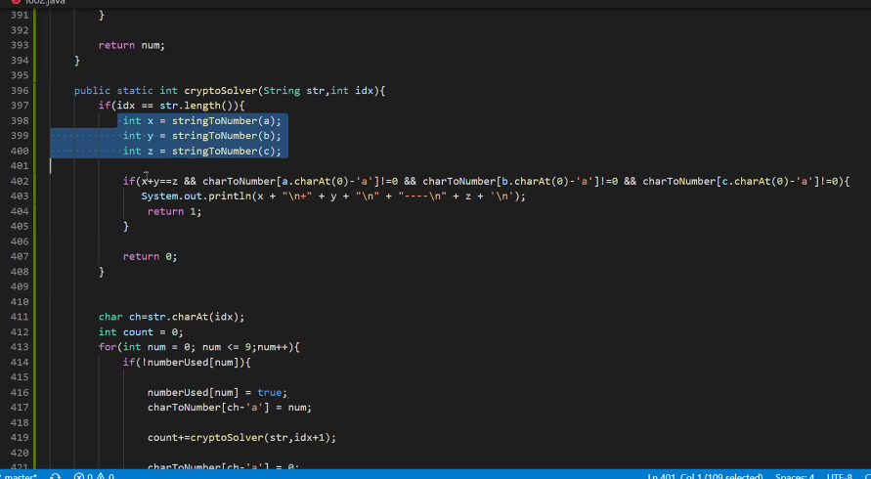

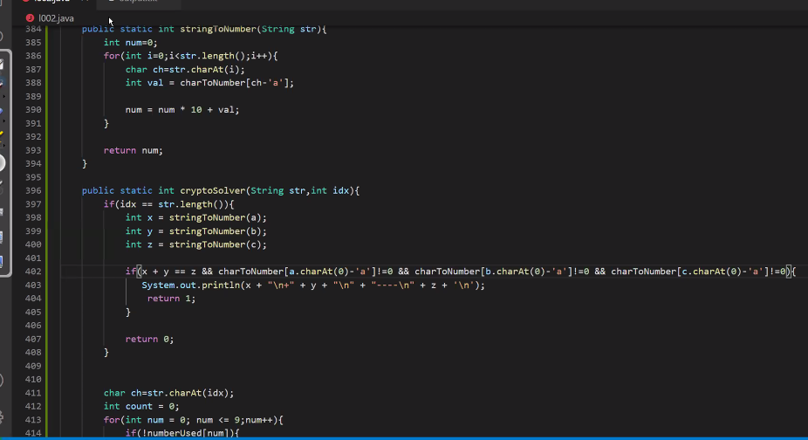



**-----------------DAY -------------2---------------RECURSIION**

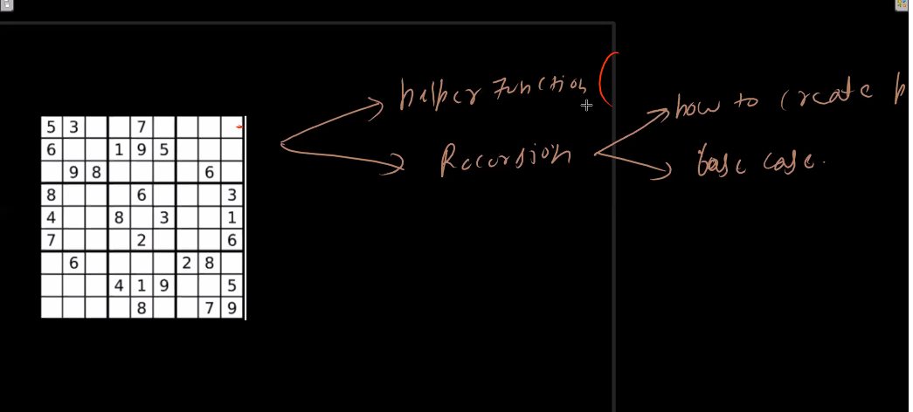

**SUDOKUE KE ANADAR HAM YE NAHI KAR SKTE KI 2 FOR LOOP USE KARE TO ITERATE OVER EVERY COORDINDATE AND HAR POINT PE RECUSION KAROO TO PLACE A NUMBER AT THAT LOCAION THIS WILL NOT GONA WORK**

**### - YE DHYAAN RKHO AGAR MAI KISI TARAH PEHLE HI YE NIKAAL Loo**

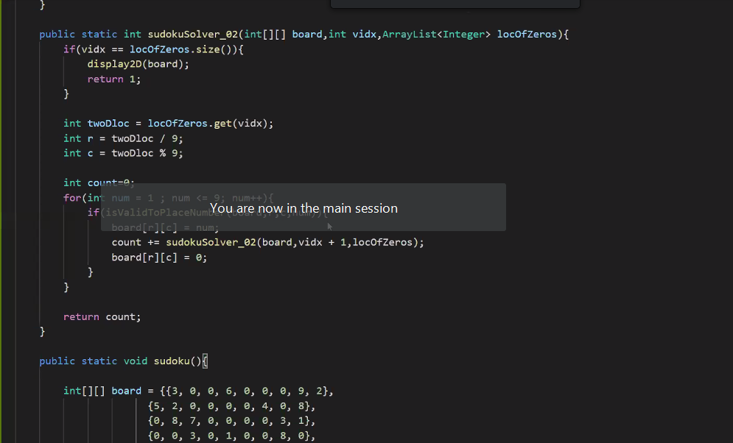

**-------------------------BIT MASKIING----------------------------------------**

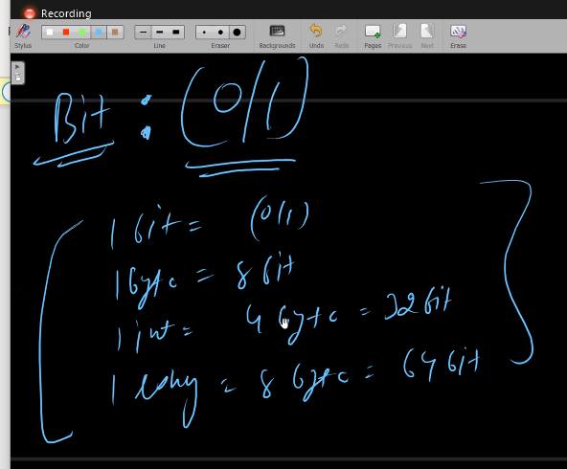

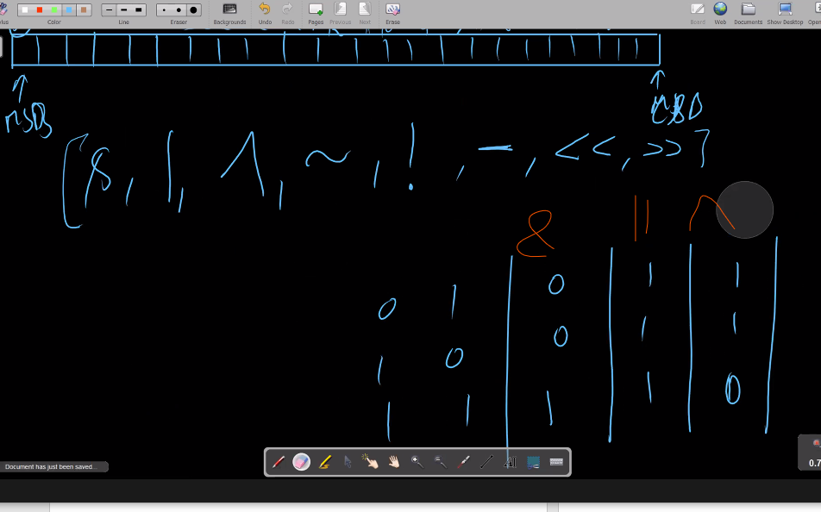

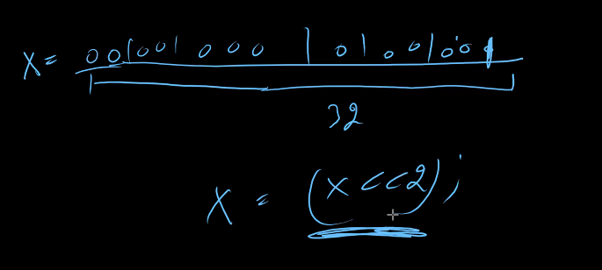

**OPERATIONS OF BITS ARE VERY WEAK SO WRITE EVERY SINGLE OPERATION IN BRACKETS**

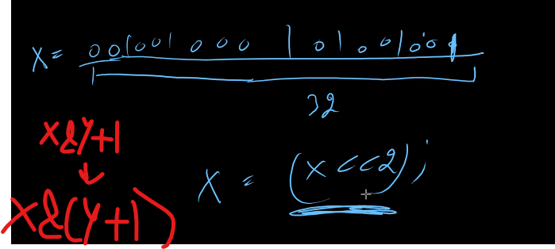

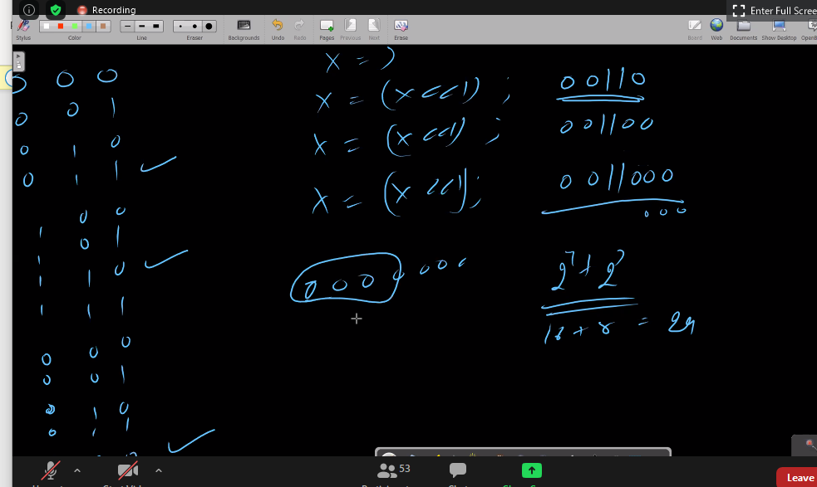

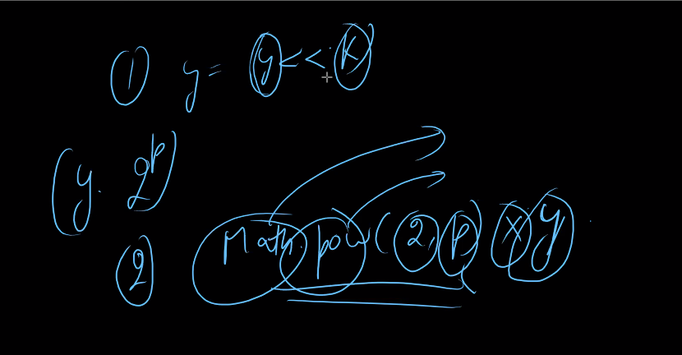

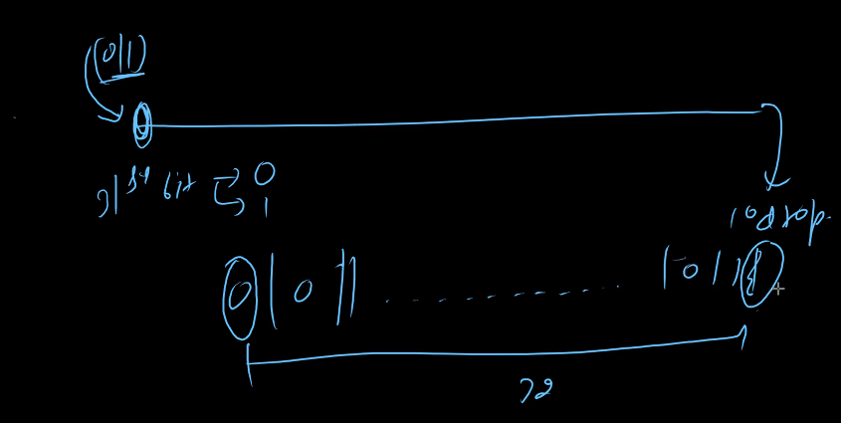

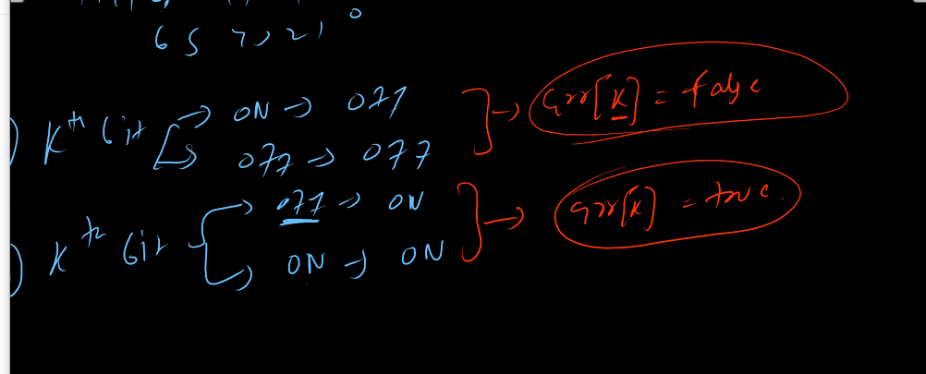

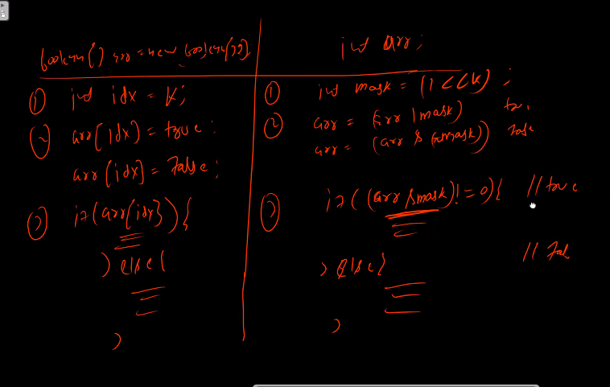

**191 , 231 , 342 , 338 ,260 , subset using bits , 137**

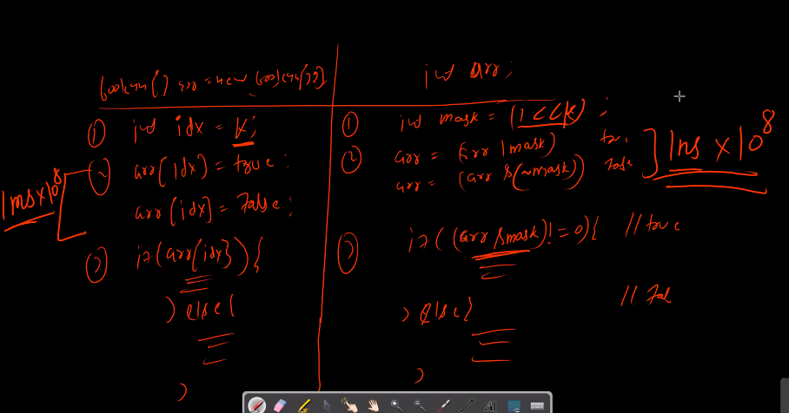

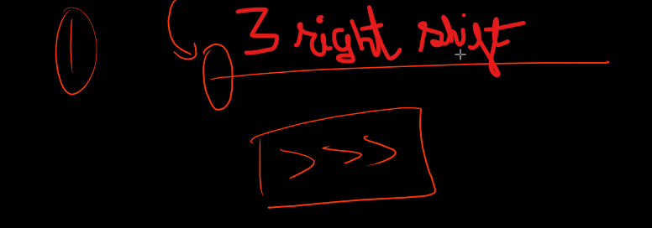

**NQUEENS USING BIT MASKINGS**

